Name: Chandrawanshi Mangesh Shivaji
Roll Number : 1801cs16
CS359 Assignment 5
Filename : Lab5_Report_1801CS16.pdf

Note: Please keep all the files in same directory before compilation as well as while usage

1. Go Back N Protocol

// Compilation details
$ gcc -o client_gbn client_gbn.c
$ gcc -o server_gbn server_gbn.c

// Run
$ ./client_gbn WINDOW_SIZE
$ ./server_gbn WINDOW_SIZE

To get reasonable output, keep WINDOW_SIZE same for both server and clientDescription:

Client :
- Send Messages along with sequence number

- Receive ACK or NAK from the server, depending on the sent message order cummulatively.

- ACK x - represents all messages from sequence number 0 to x are successfully received by the server

- In the ACK scenario user may send messages from sequence number x + 1 (hopefully in order)

- NAK x - represents that message x is not received by the server, all messages from 0 to (x-1) are successfully received

- In the NAK scenario user may send messages from sequence number x again in order

Server:
- Receive Message along with sequence number from the client

- In case of inorder receipt of messages, send ack with last received sequence number
- In case of out of order receipt of messages, send nak with expected sequence number

Example1 : Result for in order transfer of messages
Example2 : Result for out of order transfer of messages

Following are command line results for both the examples sequentially.
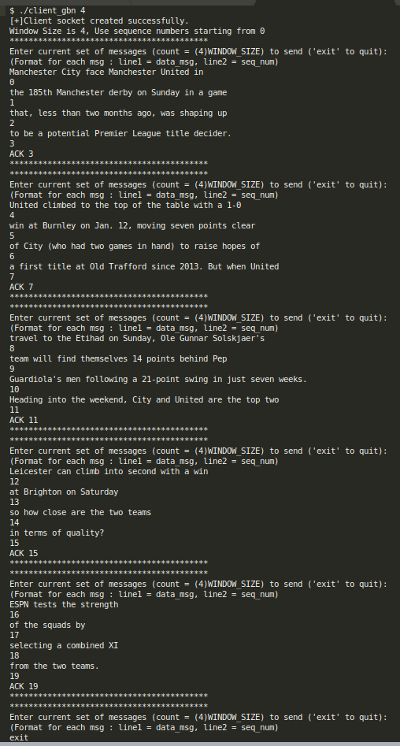
1. Client Side (inorder gbn)
1.Server Side (inorder gbn)
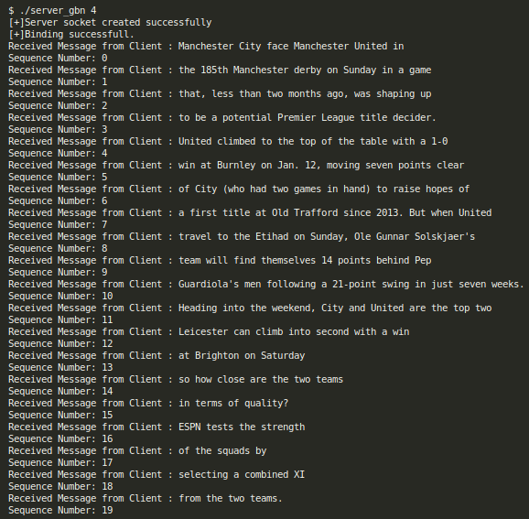
In the above example, all messages are transferred sequentially by client without in sequence number error. All are received and displayed on server side. Commulative ACK is send by the server after each window transfer.

2. Client Side (out of order gbn)
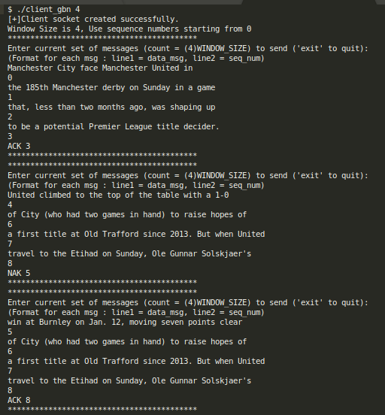
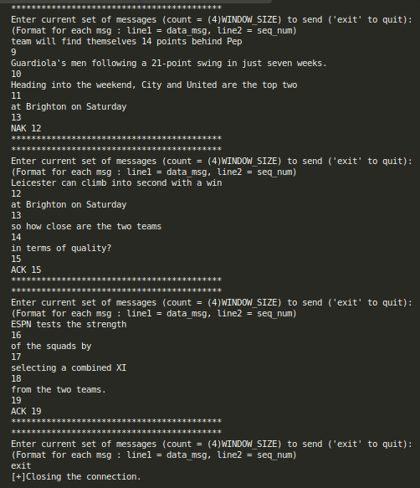
2. Server Side (out of order gbn)
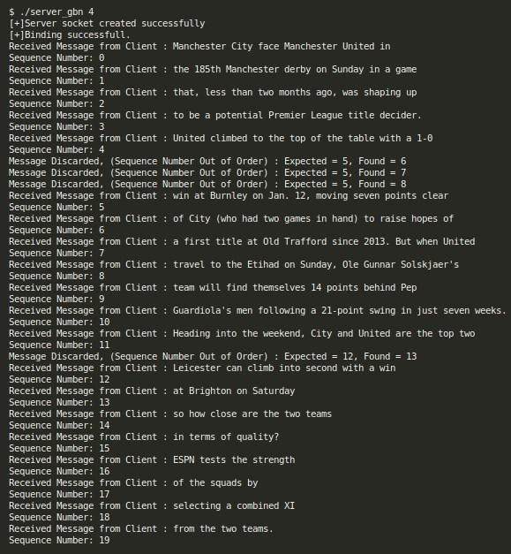
In the above example, messages with sequence number 5 and 12 are skipped by the user initially. In this case server discards all the messages in the current window and sends NAK with expected sequence number to client. Client then resends messages in appropriate order and receives cummulative ACK.

Wireshark Analysis For Go Back N

// See Packet Capture files in zip
Caputer File for Example 1 : go_back_n_inorder.pcapng
Capture File for Example 2 : go_back_n_outoforder.pcapng

Total Packets Capture in Ex1 = 45 and in Ex2 = 54

So, 2 incorrect sequence number orders result in additional 9 packets, as we have to send many messages in the current windw which are discarded again.
2. Selective Repeat Protocol

// Compilation details
$ gcc -o client_sel_rep client_sel_rep.c
$ gcc -o server_sel_rep server_sel_rep.c

// Run
$ ./client_sel_rep WINDOW_SIZE
$ ./server_sel_rep WINDOW_SIZE

To get reasonable output, keep WINDOW_SIZE same for both server and client
Description :

Client:
- Send Messages along with sequence numbers

- Receive ACK or NAK from the server, depending on the sent message order for each message

- ACK x - represents message with sequence number x is successfully received by the server. If all are ACK, user may send messages from sequence number x + 1 (hopefully in order)

- NAK x - represents that message x is not received by the server. If any one is NAK , user may send message with sequence number x first, and then follow previous order no need to send all packages from x+1 again

Server:
- Receive messages along with sequence numbers from client

- If message sequence number is not expected (out of order) and buffer is not full, buffer the messageand store sequence number

- else display the message along with sequence number, along with all previouly buffered messages and sequence numbers if present

Example1 : Result for in order transfer of messages
Example2 : Result for out of order transfer of messages

Following are command line results for both the examples sequentially.

1. Client Side (sr inorder)
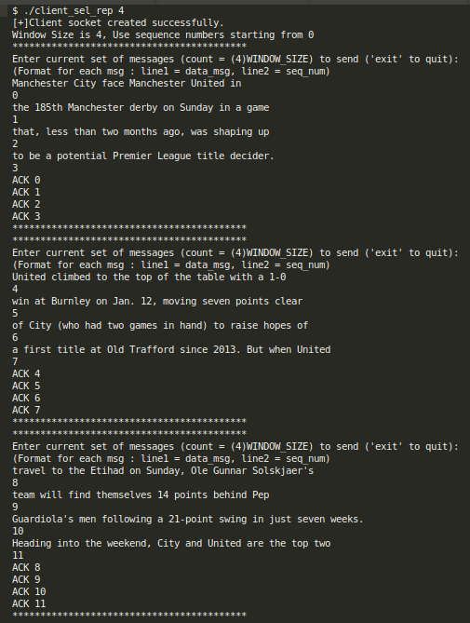
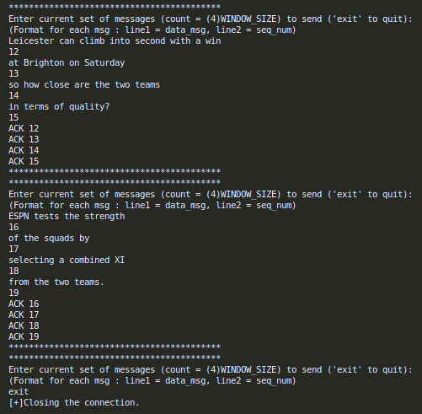

2. Server Side (sr inorder)
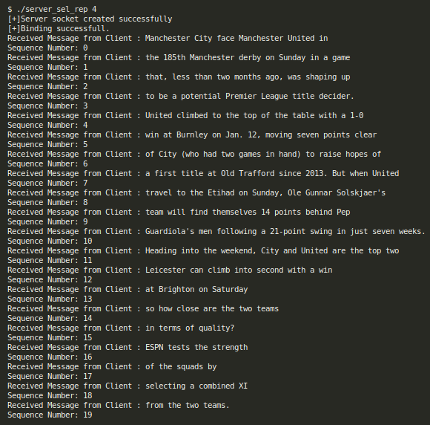
In the above example, all messages are transferred sequentially by client without in sequence number error. All are received and displayed on server side. Individual ACKs for each message are send by the server after each window transfer.

2. Client Side (sr outoforder)
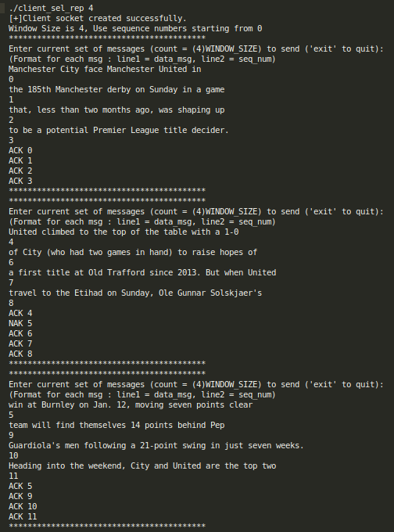
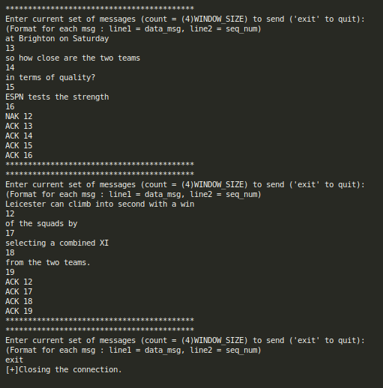
2. Server Side (sr outoforder)
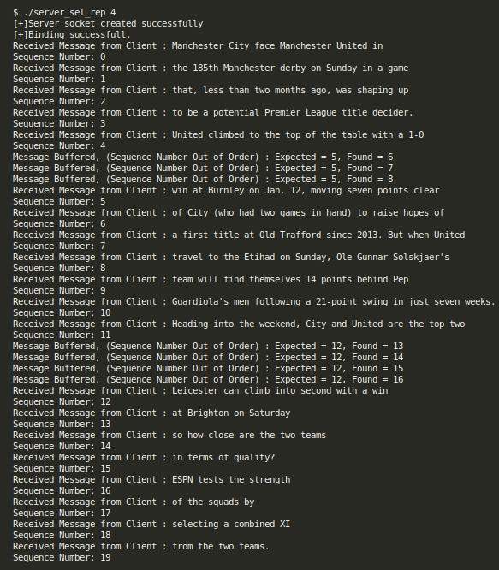
In the above example, messages with sequence number 5 and 12 are skipped by the user initially. In this case server buffers all the other out of sequence messages in the current window and sends NAK for 5 and 12 and ACK for all other displayed and buffered messages. Client then sends messages with NAK (along with other messages ahead) and receives individual ACK.

Wireshark Analysis For Selective Repeat

// See Packet Capture files in zip
Caputer File for Example 1 : selective_repeat_inorder.pcapng
Capture File for Example 2 : selective_repeat_outoforder.pcapng

Total Packets Capture in Ex1 = 60 and in Ex2 = 62
So, 2 incorrect sequence number orders result in additional 2 packets, as we have to send only messages out of sequence.

